Analyzing the distribution of food bank

based on year, locality

Name: Vivek Kumar Koundinya Atchutanna

Gno: G01506786

Instructor: Professor Schmidt

**Abstract:**

**Analyzing of use of food banks on basis of year, locality, seasons. As we have the year of 2019-2020, we have analyzed the impact of covid on the distribution of food.** Through this dataset, we get a chance to explore the patterns, trends, and challenges associated with food distribution across the state **We have formulated three research questions one is to** investigates on how the food distribution varied across locality over change in time. we wanted to see how covid impacted the food distribution and consumption mainly in the year 2019 and 2020. we have a data of month’s in every year using that we can see how seasonal changes effects food distributed.

**Initially the dataset we used had a missing value. So, we need to eliminate them to get trends correct. So, we used python programming language to eliminate them. Later used r programming to get the visualizations. To achieve the answers for the research question we used maps, bar, line graphs and scatter plots.**

1. **Introduction:**

The collection of facts and statistics together for an analysis is called data. The five steps to better data are cleaning preparation, procession, interpretation, and storage. Each step is interlinked to each other [1]. Collecting data is the first step in data processing. Once the data is collected, we must prepare it for our research requirement.  The data initially collected was raw data which needed to be cleaned by interpolation process, eliminate the duplicates, and null the data [1]. The preparation process then leads to data cleaning, it’s the process where we eliminate the null, duplicates and rename our column name and more which helps to enhance the data standard and give better results. Later, we interpret the answer to the question we have from the dataset. And finally we storage and it’s the final stage in the data processing [1].

The dataset used for the analysis is related to food bank from Virginia's open-source data platform. It’s a portal which gives access to many datasets, visualization and more [2]. The dataset consists of 14 columns and 4259 rows and it contains information on locality, year, amount of food distributed, households served, geo point and more information which is essential and helps to understand data well.

The motivation for this dataset is it deals with the most important and required element in mankind which is food. This data serves and tracks the food. Through this dataset, we get a chance to explore the patterns, trends, and challenges associated with food distribution across the state. And dataset is between the years 2019-2021 and it’s a very crucial period during the COVID-19 pandemic to explore the analytics and see how it changes. And the year is further divided into months and see the seasonal changes in the food distribution dataset. The problem statement for the research is Understanding Patterns and Determinants of Food Distribution Needs Across Virginia Over Time.

Importance of doing a research on this dataset is it address the key issues by providing insights into foodbanks and their distribution. Analysing the data embark better use of resources and update the food according to changing trends, also reduce the food wastage. Helps to understands by analysing the data and see how the food is consumed in varies seasons. Used to measures the effectiveness of food distribution programs. By analysing the data we can add new location or increase the facilities in the location where consumption in higher. Helps as a measure to the effectiveness of food distribution.

According to dataset, this paper like to investigates on how the food distribution varied across locality over change in time. Dataset has all the information related to it. To solve this problem we use year, month, locality, pounds of food distributed, Households served. Secondly, dataset is situated in the years 2019-2021 from this data we can how covid impacted the food distribution and consumption mainly in the year 2019 and 2020. Finally, we have a data of month’s in every year using that we can see how seasonal changes effects food distributed.

**1.1 Data Cleaning:**

The data is taken from the Virginia open data portal and it’s the raw data. And to analyse the data to and get insights with accuracy. Data cleaning is a process where we cleaning the missing, duplicates in the data and improve the accuracy of model [3]. The raw data set downloaded has many null values and has long column names.

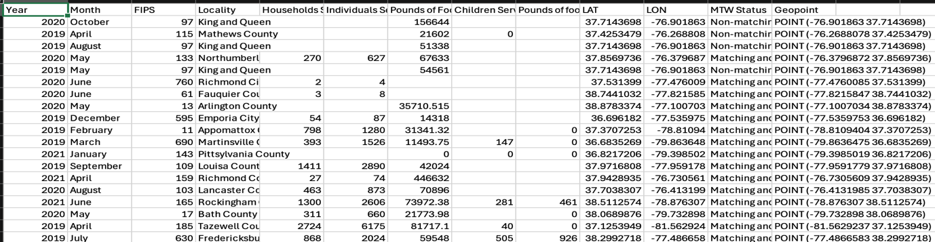Fig1 : initial dataset with null values

To clean the data we used python programming language. Imputation is method where we used the mean, median , mode to replace the null values of the row. Do this we need consider the how data is distributed. It has a potential to increase bias [4]. Firstly, we figured out the number of null values present in the dataset and it counts null values in every columns and displays the total number.

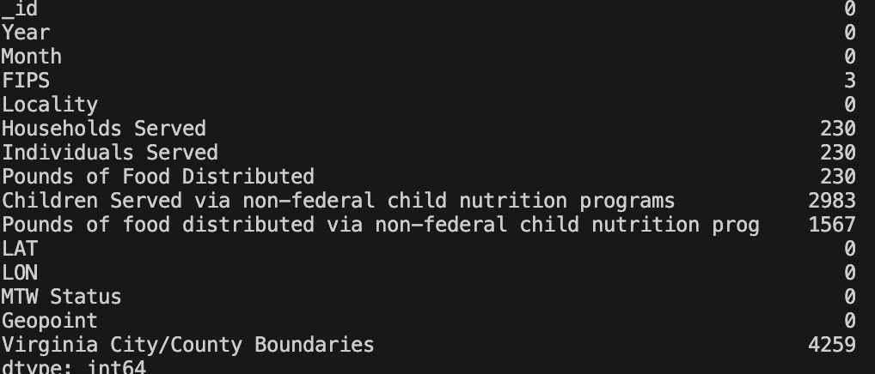

Fig2 : Count of null values per column

As the part of cleaning the data we eliminated Virginia city column because it has no record and removing the column it doesn’t affect the dataset. Locality column also has a missing values but column has categorical data so we replaced all the null values with miscellaneous. We used imputation method for columns FIPS, house served, individual served and pound of food served replaced the null values with mean of the respective column. We replace zero in place of null in columns children served via non-federal and pounds of food distributed because it’s a programme served by non-federal and we doesn’t have any information of the food served. We have eliminated the null values from the dataset but, we have lengthy column names. They were no duplicate results found in the dataset

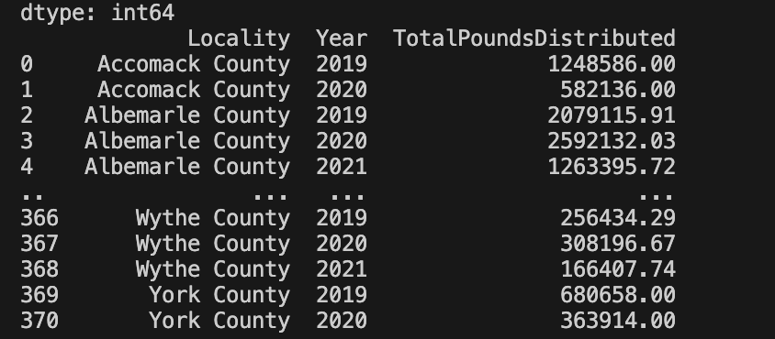 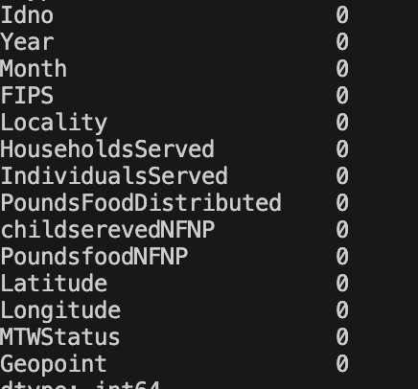

Fig3 (on left): Dataset after cleaning || Fig 4 (on right): count of null values

* 1. **NOIR Data Types:**

|  |  |
| --- | --- |
| **Column** | **Data Type** |
| Idno | Ratio |
| Year | Interval |
| Month | Ordinal |
| FIPS | Nominal |
| Locality | Nominal |
| HouseholdsServed | Ratio |
| IndividualsServed | Ratio |
| PoundsFoodDistributed | Ratio |
| childserevedNFNP | Ratio |
| PoundsfoodNFNP | Ratio |
| Latitude | Ratio |
| Longitude | Ratio |
| MTWStatus | Nominal |
| Geopoint | Ratio |

In the dataset idno is used as a indent or a count of entries of food banks. Year, month is used to track the time-period of the information. FIPS (Federal Information Processing Standards) which is a has coded to say the information US states are identified by a 2-digit number, while US counties are identified by a 3-digit number. Locality is used to name of county where the food bank is present, households served, individual served, pounds of food distributed are used to track the information of food served among people. In the dataset we used NFNP to determine non-federal child nutrition programs and childrenserevdNFNP, PoundsfoodNFNP is a nutrition program in this locality during this month and year used to know the children , pounds of food served under it [5].

1. **Literature Review:**

To address the research problems a survey of the material of recent research was performed. This review turned up three relevant academic studies.

1. There is research happen on the role of food bank in addressing food insecurity. The main objectives of the research paper are to investigate how food bank is providing sufficient food which helps to reduce the hunger and food insecurity [5]. This research paper also focus on how the programs are meeting the nutritional needs. The data collection has happened by a systematic search approach in which we identify the relevant articles. And the search identifies the relevant articles, and these are the raw data. In that data they are duplicates, missing the criteria and more. Through the research the paper says food banks kelps in decrease in food insecurity and provide culturally appropriate and suitable food [5].
2. The paper primary focus on how food bank drive-through distribution during covid-19. The COVID-19 pandemic has created an unprecedented effect on the food security and rise in the demand for food. In this research paper used racial and ethnic worsen to see the impact of people effected to the pandemic. According to the research federal nutrition assistance programs like the supplemental nutrition assistance program are not able meet the food requirements. For the research they have conducted a survey and collected the data between April and May. The questions were are related to food share programme. The pandemic present an opportunity for food banks to reduce stigma and reduce food insecurity [6].
3. The research reviews the impact of eating local seasonal food. It’s crucial to evaluate the effect the consumption of these food on sustainability. The programme in designed as a bit cover 96 rural village so that it is situated at place where all the storage, credit and contract storage [7]. The data for this is taken large house hold panel which were surveyed in the span of 3 years. They used all the demographics of different ages, education, marital status. And used the data collected to how consumption of households vary across seasons and our findings cannot be explained by expected differences in seasonal prices or differences in seasonal festivities [7].

As our dataset has all the components to analyse the research questions we also have the data for year before covid and data of every month In covid that will help us make more useful findings. We can compare the statistics in-between following year. As coming to seasonal trends we have months which are used to produce the trends.

1. **Research Questions:**

We have formulated three research questions based on the data, aimed at extracting valuable insights and deepening our understanding of the underlying trends. In this section we will discuss in details.

Firstly, research question is about how the food distributed depends on locality and how it changed with time. Through this question we aim to find how food is distribution varies with time. To achieve this we need the information of time (year, month), statistics of food distribution ( The food distribution is calculated with helps household served and individuals served. To understand the localities where the food banks are located we used maps visualizations, which helps to see how many foodbank is close to one locality. There are some areas with cluster of food banks located at a same place.

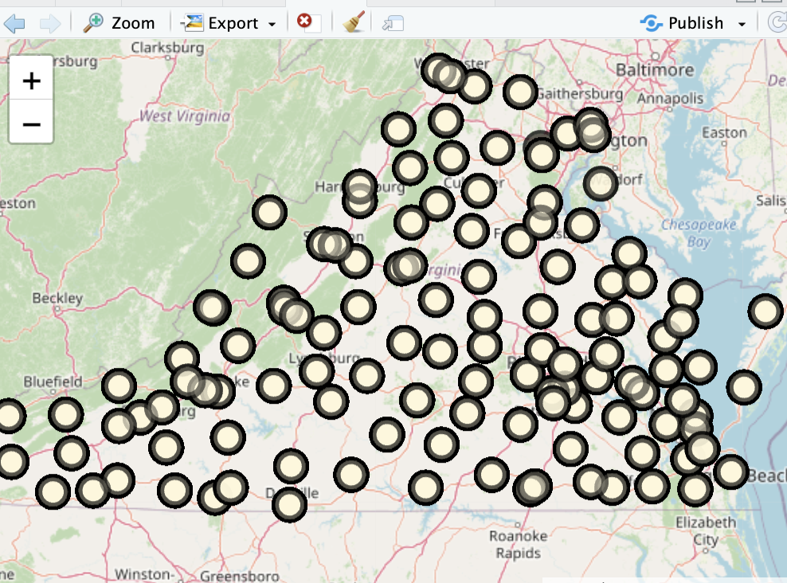

Fig5 : Visualisation of food banks based on locality

To address the research questions we have created a subset with localities and year and used sum method to summarize the pound of food distributed in a year and further separated by localities.

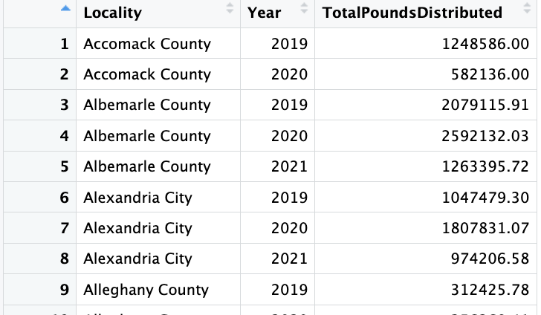

Fig6 : Subset of original dataset used to analyse

We analysed the relationship between the year and the total pounds food distributed across various localities using a bar graph in the visualization. The graph compares different places and shows the distribution trends over time. We also did it for households served which is also a factor food distribution.

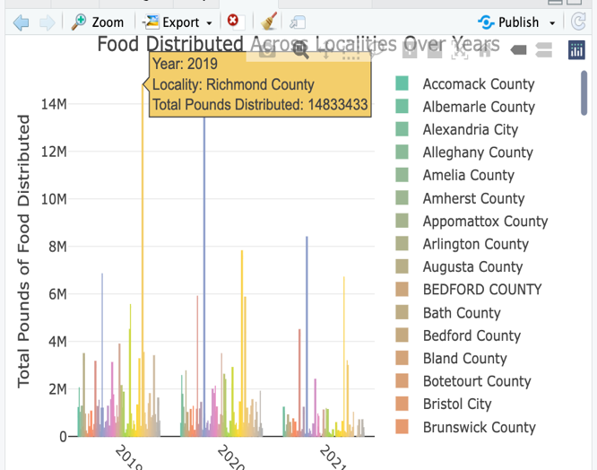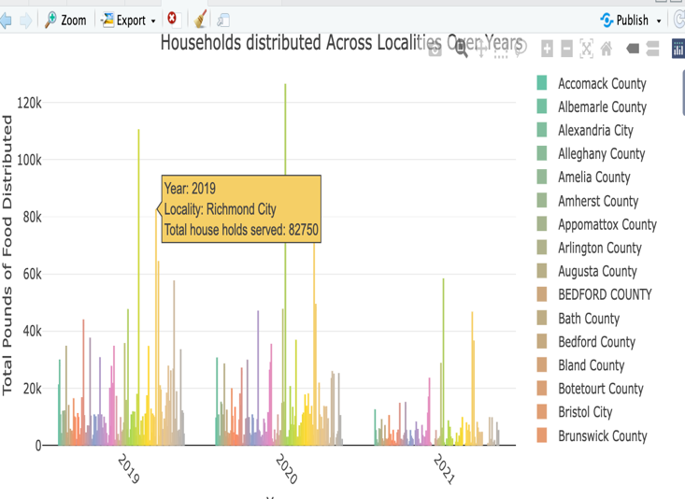

Fig7 : pounds of food distributed per locality and year || Fig8: households served per locality and year

In food distribution Norfolk county highest in 2019 and in 2020 lunch burg city has the place of First position. After comparing some localities for example Richmond county. For food distribution the county has seen a rise the pound of food distributed. Whereas some county’s like Chesapeake it shown a dip in year 2020 when compared to previous year. In the aspect of households served Norfolk is the county with highest house hold in the year 2019 and 2020. There are some fluctuation similar to trends in food distribution for instance Richmond county has 82k households served in the year 2019 and the number has increased to 93k in the year 2020.

We used another visualization in which we use a year summary of pounds of foods distributed In with we used the year component and summarize the total pounds of foods distributed. We also did the same with the households served.

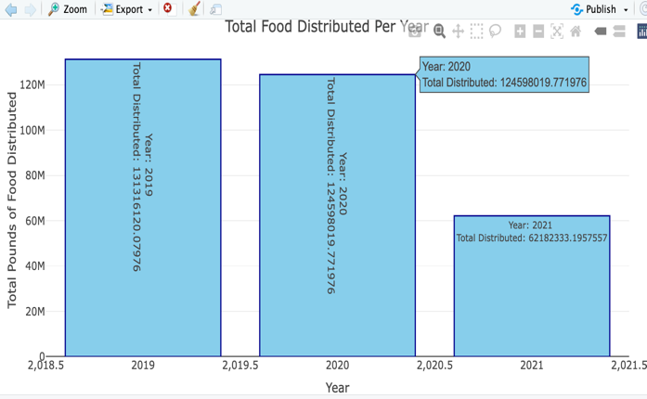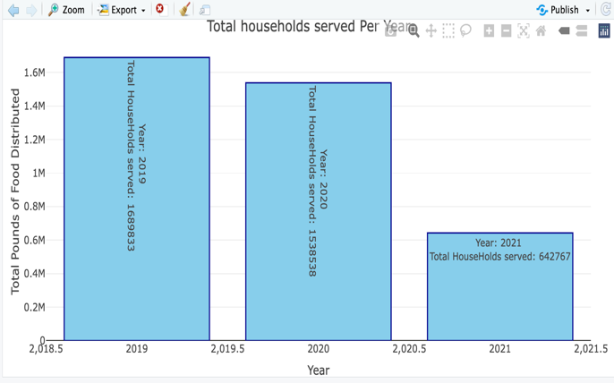

Fig9: food distributed per year || Fig10: households served per year

Secondly, next research focus on how the covid – 19 pandemic impact the food distribution. The dataset is divided into three years and data starts from 2019 and ends with the year 2021. Where we know 2020 is the year where the pandemic is highly spread across the world. By analysing this data, we can assess how food distribution has changed in response to the pandemic. We can create scenarios to compare food distribution patterns across different localities and time periods. TO achieve this we need the information of time (year, month) mainly 2019-2020, statistics of food distribution ( The food distribution is calculated with helps household served and individuals served.

To achieve the research questions we need to compared the difference in-between the year 2019 and 2020 by compared to localities. And created a subset with localities and year and Found the difference between pounds of food distributed across two years. And also we added a status column where we names positive change as increase and negative change as decrease.

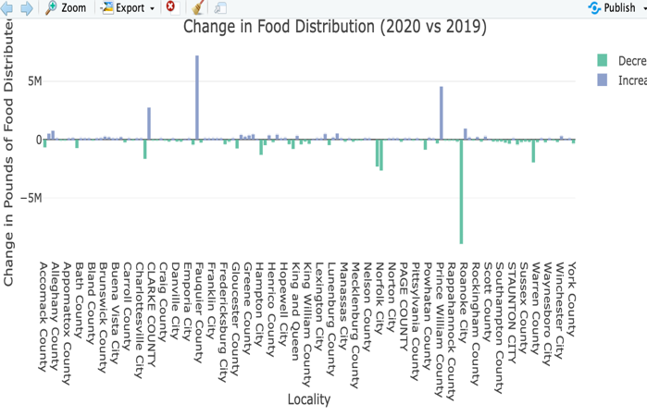 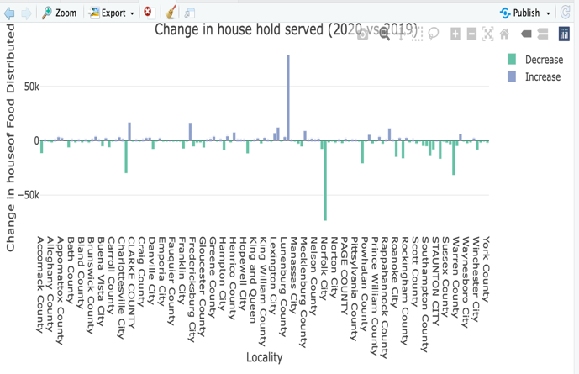

Fig11: change in food distributed per year and locality || Fig12: change in households per year and locality

Fairfax county has the positive change with 71k. On the another hand Richmond county seen the highest decrease in the following years.

As per the visualizations for households served Lynchburg city has the increased exponentially with positive increase of 78k. Norfolk city seen the decrease with 73k. From the analysis in the sector of households served 73 localities have not met their requirements and decreased from the previous year. But, when it comes to pounds of food distribution many localities have served more than the previous year.

We used heat map to see the how close are the food banks located and see area in which county’s served more than compare to other and also used a time factor to track it. In a heat map area with red colour has high intensity and yellow has moderate and more.

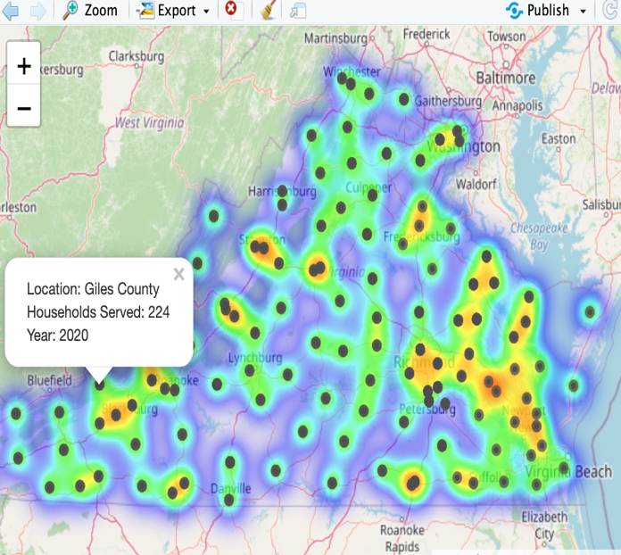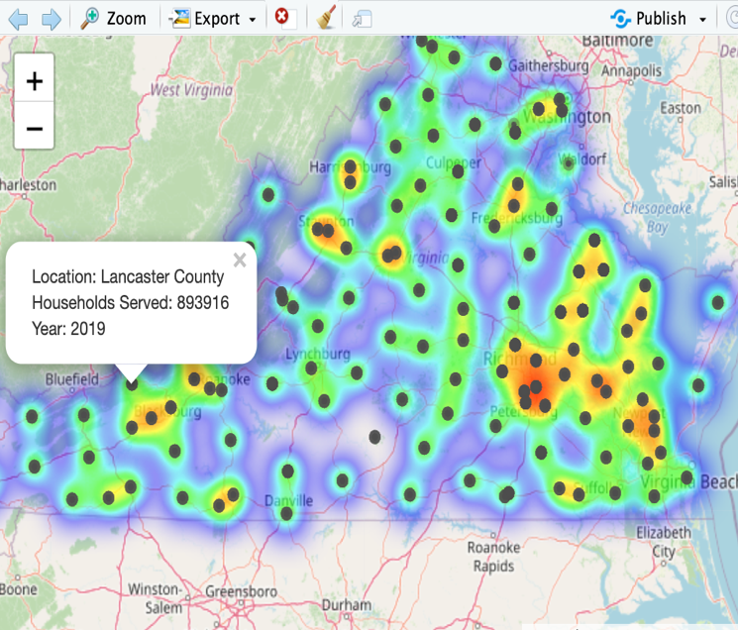

Fig13: heat maps of households per year and locality || Fig14: heat maps of food distributed per year and locality

Finally, the third research question is about how a seasonal change has impact on food distribution. To achieve this research question we have created a subset with localities and year. To achieve this we need the information of time (year, month), statistics of food distribution ( The food distribution is calculated with helps household served and individuals served. And also did the change in season on the basis if months such as December, January this season they fall under is winter. In the same way we did for every season.

We used line chart to see the trend in change in sum of food distribution on the basis of months and we used three lines in visualisation which are used as the year’s.

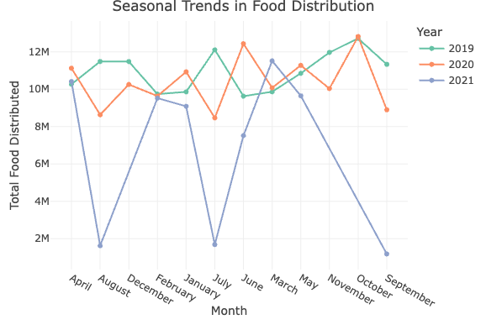

Fig15: line chart of seasonal change of food distribution in months and years

By the above visualization we can see how every month in every year is changes. In the month of February, all year have same trend of 95k pounds of food distribution. In the month of august, 2019 has the highest number of food distribution where as 2020,2021 have not reached . Whereas in October the 2019,2020 has shown the same trend in the food distribution but 2021 has been very low.

In the another graph we further create a subset of season where we used month. We used whole dataset and create a column called seasons and we predefined that if a month is (December", "January", "February”) it’s a winter, (“September", "October", "November" as fall season and more. The we have create a subset of year, seasons and sum of food distributed in pounds.

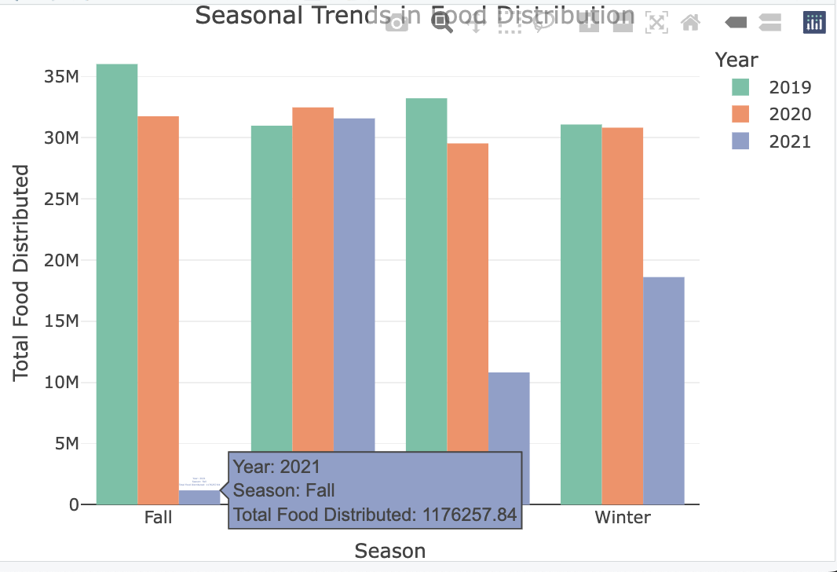

Fig15: bar chart of seasonal change of food distribution in months and years

By this analysis we can say that in fall season more amount of food id distributed In 2019 with and next comes 2020 and then 2021. Fall 2021 is the lowest among all the season the visualisation. On the other hand, in spring season 2020 has the highest food distributed and 2021 and 2020 almost distribute same amounts but 2021 has distributed slight higher. Summer and fall have same trend by 2019 has the highest next comes 2020 and then 2021 but, the difference 2020 and 2021 is not too high. The winter season 2019 and 2020 similar trend but 2019 has distributed slight higher.

1. **Uni-Variant and Multi-Variant :**

Univariant analysis is the simplest dorm of analysing the data. The analyse in which involve visualising a single variable at a time without any relationship. It helps in understanding the distribution, central tendency like mean, median, mode. The common univariate visualisations are histograms, boxplot, density plot [9].

On the another hand, multivariant analysis is method of gathering multiple variable and analysing and drawn the conclusion through them. The multivariant are the relationships involve the relationship between multiple variables. And helps to understand interaction, correlation, trends among variables. Most commonly used visualisations are scatter plot, Pair plot, heat map [10].

**4.1 Uni-Variant visualisations:**

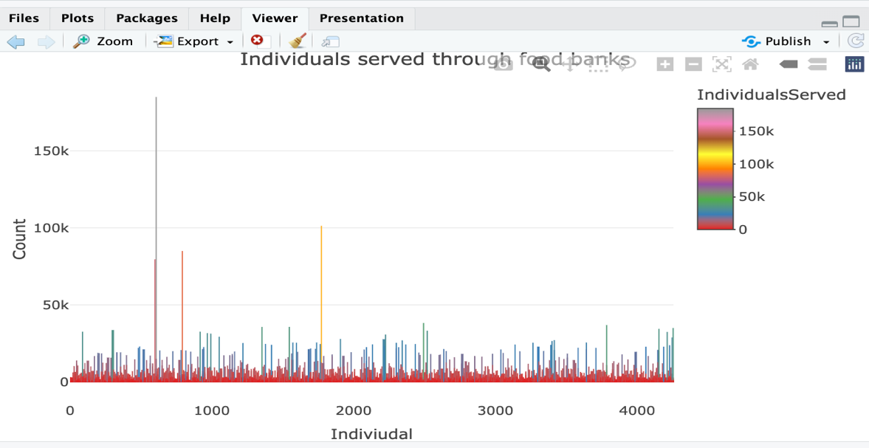

This is a univariant visualisation. In this we used individuals served as the column and performed a bar graph. To see how the individuals vary in the dataset. By this graph we can see how individual served changed and in the x axis we see how it the individuals served in the dataset and in y axis we see the count of the individuals served. The individual served Is the colour coded and we can see the as the indicator most of the visualization in close to 0 – 150 members as a result the most part visualisation is in red colour.

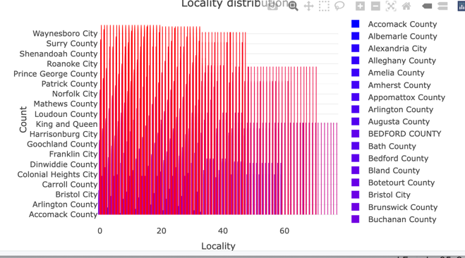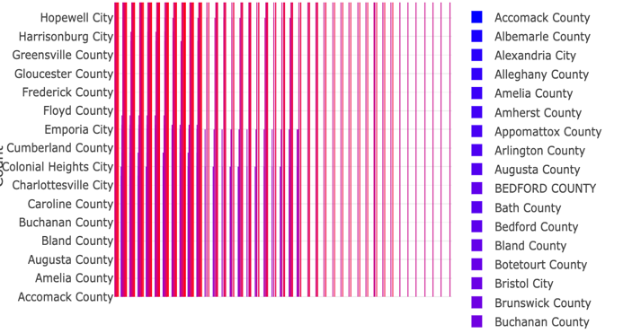

We used locality variable and did a univariant visualisation. Locality variable comes under nominal datatype. We used red and blue colours to show the high’s and low’s in repetition of dataset. It helps to understand how many locaties have high repetition in the dataset.

**4.2 Multi-Variant visualisations:**

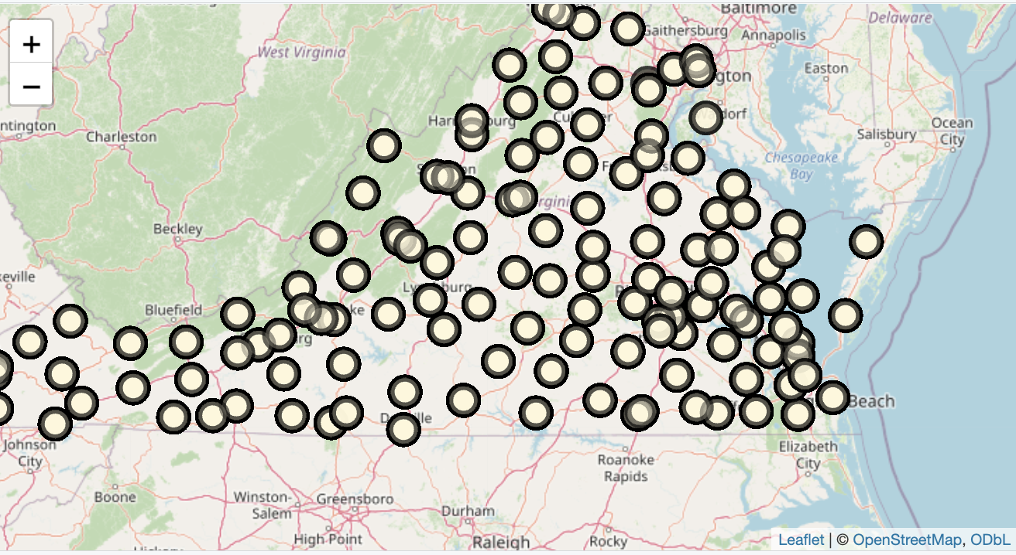

This is also an example of multi-variant visualisation. In this we used locality and geo points to see how far or close a food bank is located to each other. We used leaflet in r to get the map and used a technique called add circles in the leaflet library. This visualisation help us to understand the how food bank located and which area is has high foodbanks.

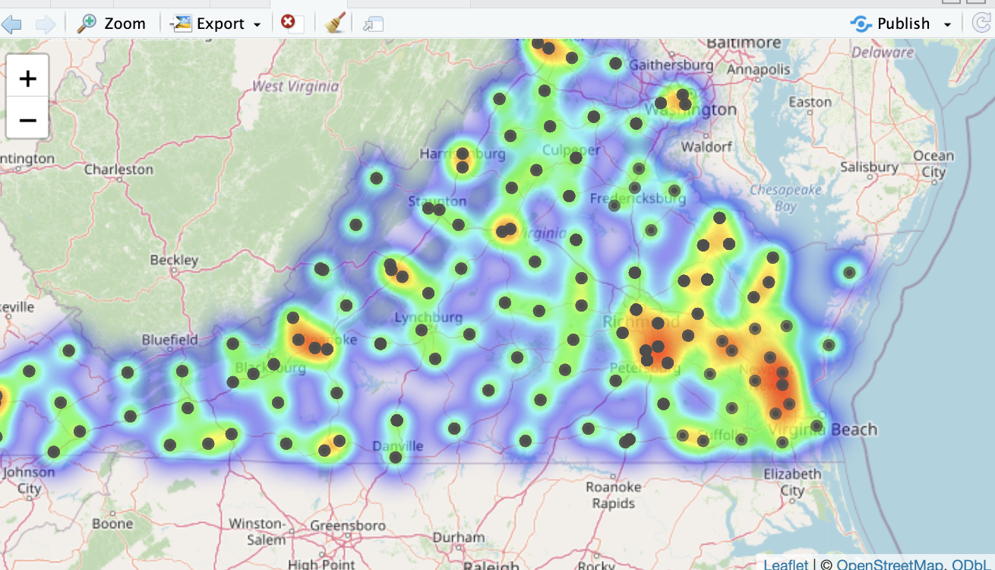

In this visualisation we used latitude’s, longitude’s and also incorporated the sum of households served to see the density of the households served. By this visualisation we can analyse the information of how the no of food banks in a locality helps in serving more food.

1. **Amazon AWS:**

Amazon AWS is cloud computing platform. It offers a wide range of on demand services such as computational power, storage, database and more instead of physical hardware. The AWS offers on demand computing which is programme where we pay on to the resources we use and no upfront cost. The services offered by aws are amazon EC2, S3, RDS and more [11].

* 1. **Amazon S3:**

Amazon simple storage service (S3) is web based cloud storage service. Which is used as the storage and backups. Amazon S3 can be used by organizations ranging in size from small businesses to large enterprises [12].

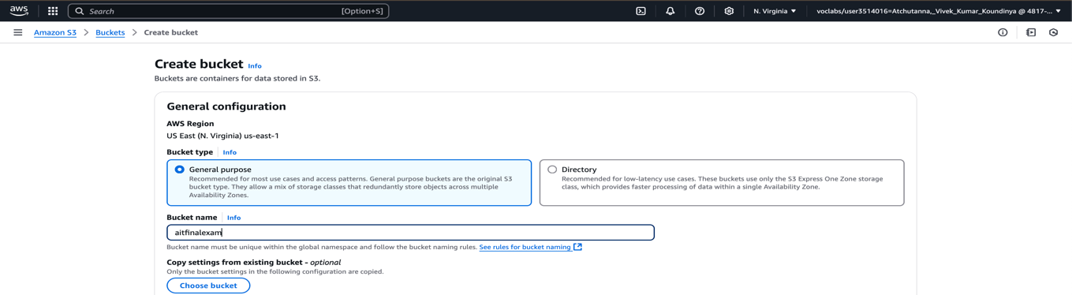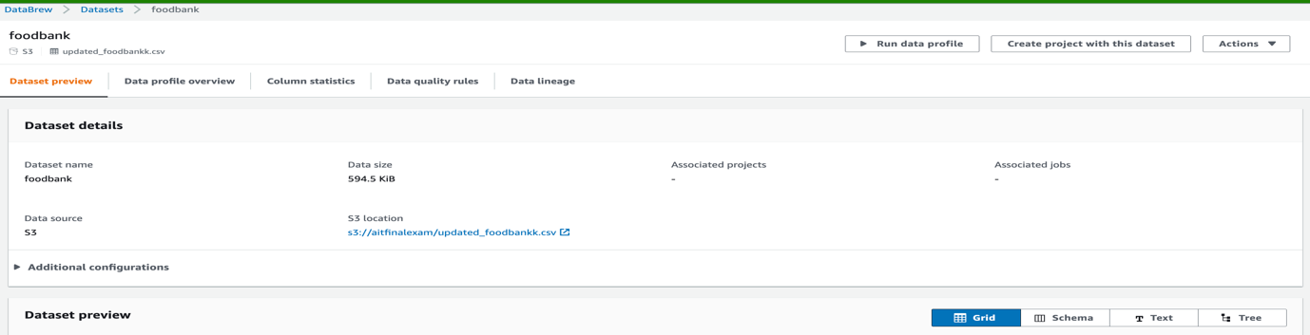

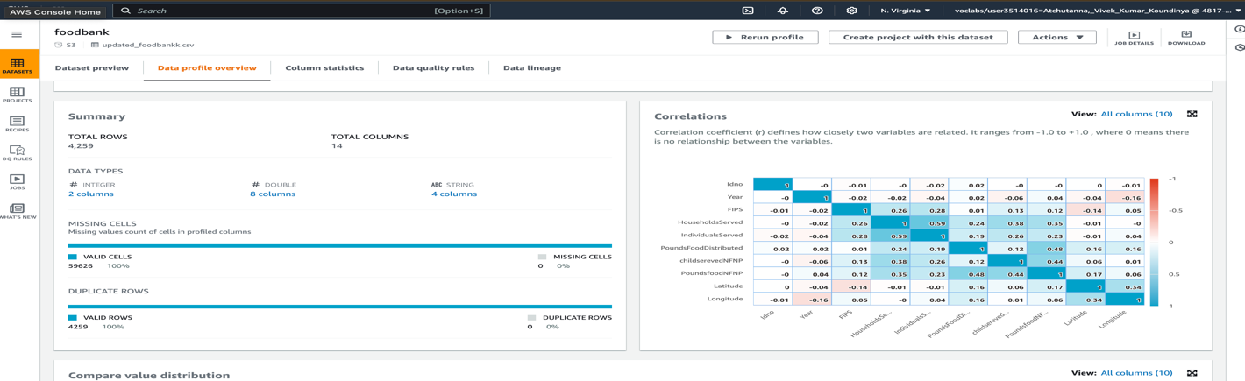

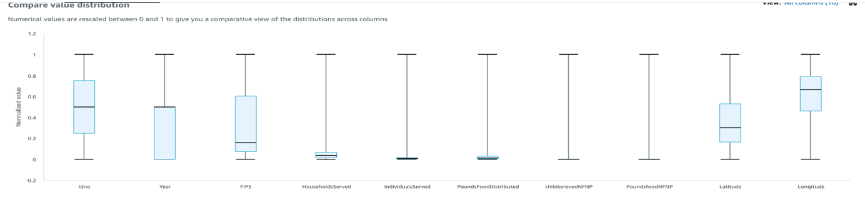

We have uploaded our dataset into s3 bucket and used amazon databrew to analyse and visualise the dataset.

* 1. Amazon RDS:

Amazon RDS is database service which is an easy to manage relational database service. It is simple to set up and it is a pay as you use model. The RDS has high availability, easy to operate [13].

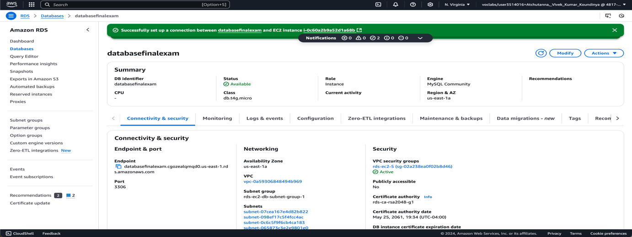

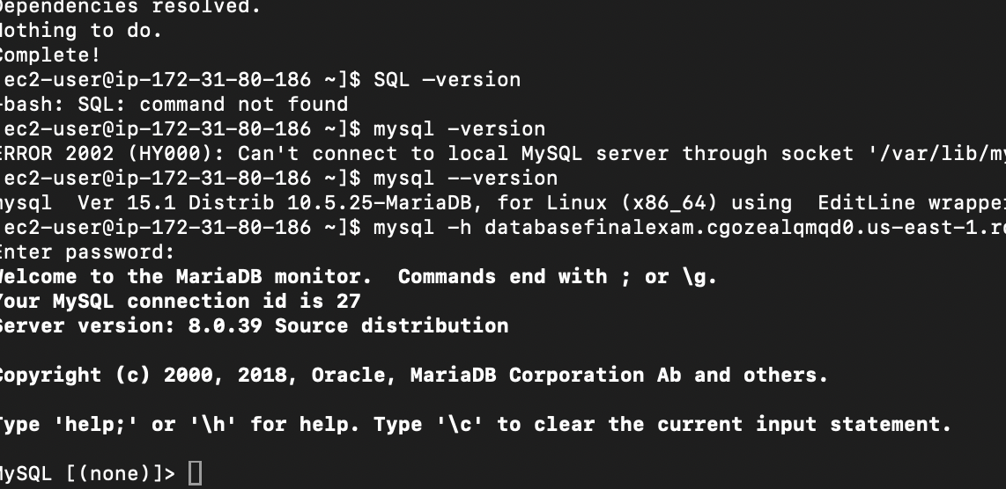

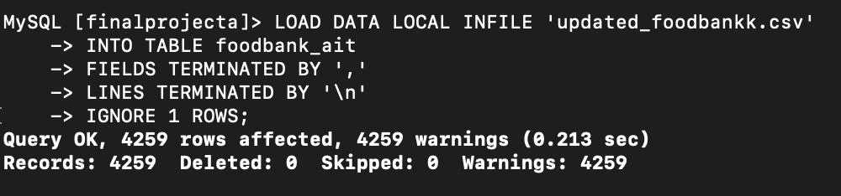

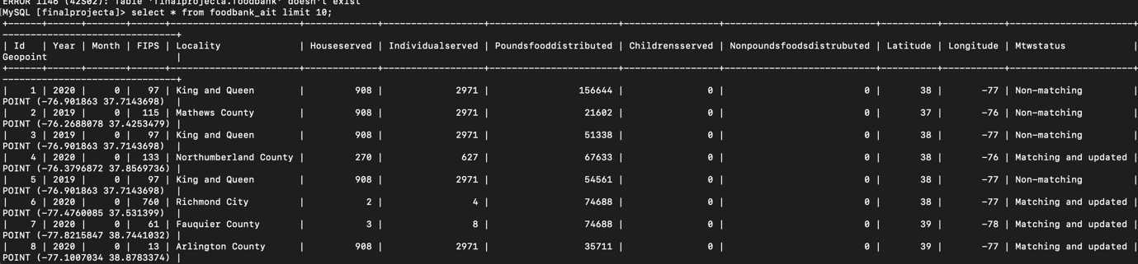

* + 1. **Implementation SQL:**

SQL (structured query language) it is a language used to store , manage the

Database. In this the information is stored in rows and columns.

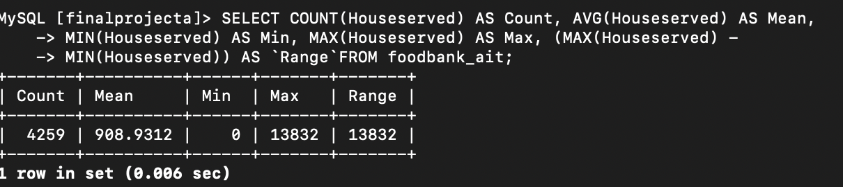

In this we used the count, min and max operations to perform the basic operation like find the mean, min and more of a column in the database. This information can be used in the analyse of the column households served.

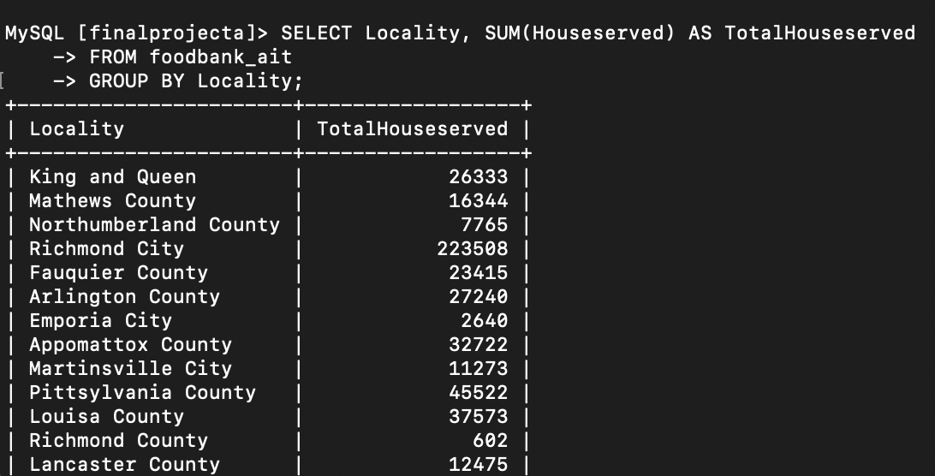

In this we have use locality and household served and we group locality and count all the households served in that locality. By this we can get that clear understanding of which locality has served the most households and more.

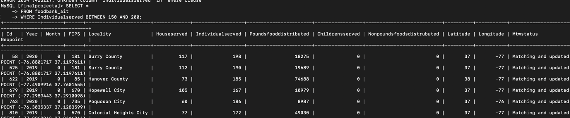

In this we did use individuals served column and between operator to extra the number of entries in between that limit. Through which we can analyse the county or locality with the lower individual served and make necessary actions to improve them.

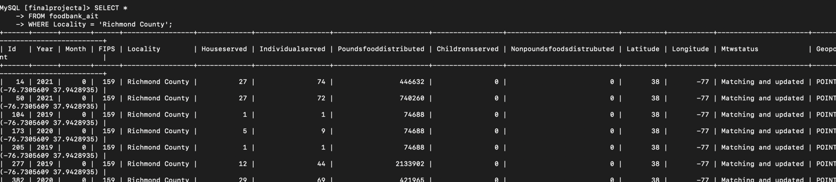

In this we have used where command and extract the data where the locality is equal to Richmond county. This is useful when we need have special focus on specific locality.

1. **Results:**

We successfully analysed the dataset and formulated the research questions. Data cleaning was performed using Python, while data visualization was carried out using R programming. Clear and actionable insights were obtained to guide decision-making or further research. The implications from the dataset is food distribution has shown an increase in the impact of covid 19 pandemic. The Season have clearly showing trend in change in food consumption. Spring is the season where most people have using the foodbanks and It’s the most consistent season in all three years.

Appendix :

Python programming code:

import pandas as pd

import matplotlib.pyplot as plt

import numpy as np

data = pd.read_csv("/Users/vivekkumar/Desktop/finalproject_ait/foodbank.csv")

print(data.head())

null_counts = data.isnull().sum()

print(null_counts)

#cleaning dataset

Updated_data = data.drop('Virginia City/County Boundaries', axis=1)

#print(Updated_data.head())

Updated_datanull_counts = Updated_data.isnull().sum()

Updated_data["Locality"].fillna("miscellaneous")

mean_A = int(Updated_data['FIPS'].mean()) # Calculate the mean and convert to an integer

print(mean_A)

Updated_data['FIPS'] = Updated_data['FIPS'].apply(lambda x: mean_A if pd.isnull(x) else x) # Replace null values

mean_house = int( Updated_data['Households Served'].mean())

print(mean_house)

Updated_data['Households Served'] = Updated_data['Households Served'].apply(lambda x: mean_house if pd.isnull(x) else x)

mean_individual = int(Updated_data['Individuals Served'].mean())

Updated_data['Individuals Served'] = Updated_data['Individuals Served'].apply(lambda x: mean_individual if pd.isnull(x) else x)

mean_pounds = int(Updated_data['Pounds of Food Distributed'].mean())

Updated_data['Pounds of Food Distributed'] = Updated_data['Pounds of Food Distributed'].apply(lambda x: mean_pounds if pd.isnull(x) else x)

Updated_data['Children Served via non-federal child nutrition programs'] = Updated_data["Children Served via non-federal child nutrition programs"].fillna(0)

Updated_data['Pounds of food distributed via non-federal child nutrition prog'] = Updated_data["Pounds of food distributed via non-federal child nutrition prog"].fillna(0)

#null values

Updated_datanull_counts = Updated_data.isnull().sum()

print(Updated_datanull_counts)

print(Updated_data)

# File path to save the updated dataset

updated_file_path = "/Users/vivekkumar/Desktop/updated_foodbank.csv"

# Save the updated dataset as a CSV file

Updated_data.to_csv(updated_file_path, index=False)

#downloading dataset

print("Updated dataset saved at: {updated_file_path}")

# Change row names

Updated_data = Updated_data.rename(columns={

'_id': 'Idno',

'Children Served via non-federal child nutrition programs': 'childserevedNFNP',

'Pounds of food distributed via non-federal child nutrition prog': 'PoundsfoodNFNP',

'LAT': 'Latitude',

'LON': 'Longitude'

})

Updated_data = Updated_data.rename(columns={

'Households Served': 'HouseholdsServed',

'Individuals Served': 'IndividualsServed',

'Pounds of Food Distributed': 'PoundsFoodDistributed',

'MTW Status': 'MTWStatus'

})

#print(Updated_data)

Updated_datanull_counts = Updated_data.isnull().sum()

print(Updated_datanull_counts)

#File path to save the updated dataset

updated_file_path = "/Users/vivekkumar/Desktop/updated_foodbankk.csv"

# Save the updated dataset as a CSV file

Updated_data.to_csv(updated_file_path, index=False)

#downloading dataset

print("Updated dataset saved at: {updated_file_path}")

#checking duplicates

duplicates = Updated_data.duplicated()

# Print the duplicate rows

print(Updated_data[duplicates])

unique_names = Updated_data['Locality'].unique()

unique_count = Updated_data['Locality'].nunique()

#print(unique_count)

# Assuming you have a DataFrame called 'df'

summary = Updated_data.describe()

R programming:

library(tidyverse)

library(plotly)

library(leaflet)

library(dplyr)

library(ggplot2)

library(leaflet.extras) # Load leaflet.extras

# Read a CSV file

data <- read.csv("/Users/vivekkumar/Desktop/finalproject_ait/updated_foodbankk.csv")

# View the first few rows

head(data)

# Checking data

colnames(data)

summary(data)

#cleaning:

# Remove the first row

household_summary2 <- household_summary[-1, ]

# Check the updated dataset

head(household_summary2)

#visualizations:

#maps:

# Create a basic interactive map

maps<- leaflet(data) %>%

addTiles() %>% # Add default map tiles

addCircleMarkers(

lng = ~data$Longitude, # Replace with your longitude column name

lat = ~data$Latitude, # Replace with your latitude column name

popup = ~data$Locality,# Replace with a relevant column for popups (e.g., Name, Address)

color = "black", # Corrected argument name for stroke color

fillColor = "cornsilk",

fillOpacity = 0.5

)%>%

setView(lng = mean(data$Longitude), lat = mean(data$Latitude), zoom = 7)

maps

#locations

year_householdsserved_summary <- data %>%

group_by(HouseholdsServed, Year, Locality) %>% # Replace with the actual column names

summarize(Count = n()) %>% # Count the occurrences

ungroup()

plot_ly(

data = household_summary2,

x = ~ Locality, # Replace with actual column name

y = ~Totalhouseholdsserved, # Replace with actual column name

color = ~as.factor(Year), # Color based on Year

type = 'bar',

text = ~paste("Year:", Year,"<br>Location:", Locality, "<br>HouseholdsServed:", Totalhouseholdsserved), # Add tooltips

hoverinfo = 'text'

) %>%

layout(

title = "Comparison of House Holds served among localities Across Years",

xaxis = list(title = "Location", tickangle = 45),

yaxis = list(title = "Count"),

barmode = 'group' , # 'group' for side-by-side bars, 'stack' for stacked bars

colorway = c("#636EFA", "#EF553B", "#00CC96", "#AB63FA", "#FFA15A") # Custom color set

)

#food

food_distribution_summary <- data %>%

group_by(Locality, Year) %>%

summarize(TotalFoodDistributed = sum(PoundsFoodDistributed, na.rm = TRUE))

plot_ly(

data = food_distribution_summary,

x = ~Locality, # Replace with actual column name

y = ~TotalFoodDistributed, # Replace with actual column name

color = ~as.factor(Year), # Color based on Year

type = 'bar',

text = ~paste("Year:", Year, "<br>Location:", Locality), # Add tooltips

hoverinfo = 'text'

) %>%

layout(

title = "Comparison of Locations Across Years",

xaxis = list(title = "Location", tickangle = 45),

yaxis = list(title = "Count"),

barmode = 'group' # 'group' for side-by-side bars, 'stack' for stacked bars

)

#research question:

#How does food distribution vary across locality over change in time ?

# We are finding food summary. In this we are doing a subset from whole dataset we take locality, year, and

#sum of food distributed in that year. and using plotly.

# to get the correctky food distribution we can use both house holds served and individuals served

food_summary <- data %>%

group_by(Locality, Year) %>%

summarize(TotalPoundsDistributed = sum(PoundsFoodDistributed, na.rm = TRUE)) # Replace FoodDistributed with your column name

# View the result

print(food_summary)

write.csv(food_summary, "Food_Distribution_Summary.csv", row.names = FALSE)

plot_ly(

data = food_summary,

x = ~Year,

y = ~TotalPoundsDistributed,

color = ~Locality,

type = "bar",

text = ~paste("Year:", Year, "<br>Locality:", Locality, "<br>Total Pounds Distributed:", TotalPoundsDistributed),

hoverinfo = "text"

) %>%

layout(

title = "Food Distributed Across Localities Over Years",

xaxis = list(title = "Year", tickangle = 45), # Rotate x-axis labels

yaxis = list(title = "Total Pounds of Food Distributed"),

barmode = "group" # Group bars side by side

)

#household

plot_ly(

data = household_summary,

x = ~Year,

y = ~Totalhouseholdsserved,

color = ~Locality,

type = "bar",

text = ~paste("Year:", Year, "<br>Locality:", Locality, "<br>Total house holds served:", Totalhouseholdsserved),

hoverinfo = "text"

) %>%

layout(

title = "Households distr Across Localities Over Years",

xaxis = list(title = "Year", tickangle = 45), # Rotate x-axis labels

yaxis = list(title = "Total Pounds of Food Distributed"),

barmode = "group" # Group bars side by side

)

#year wise:

yearly_summary <- food_summary %>%

group_by(Year) %>%

summarize(TotalPoundsDistributed = sum(TotalPoundsDistributed))

print(yearly_summary)

plot_ly(

data = yearly_summary,

x = ~Year, # X-axis: Year

y = ~TotalPoundsDistributed, # Y-axis: Total Pounds Distributed

type = "bar", # Bar chart

text = ~paste("Year:", Year, "<br>Total Distributed:", TotalPoundsDistributed), # Hover text

hoverinfo = "text", # Display custom hover text

marker = list(color = "skyblue", line = list(color = "darkblue", width = 1.5)) # Bar styling

) %>%

layout(

title = "Total Food Distributed Per Year",

xaxis = list(title = "Year", tickangle = 0), # Rotate x-axis labels if necessary

yaxis = list(title = "Total Pounds of Food Distributed"),

template = "plotly_white" # Minimal, clean theme

)

yearlyhousehold_summary <- data %>%

group_by(Year) %>%

summarize(Totalhouseholdserved = sum(HouseholdsServed))

print(yearlyhousehold_summary)

plot_ly(

data = yearlyhousehold_summary,

x = ~Year, # X-axis: Year

y = ~Totalhouseholdserved, # Y-axis: Total Pounds Distributed

type = "bar", # Bar chart

text = ~paste("Year:", Year, "<br>Total HouseHolds served:", Totalhouseholdserved), # Hover text

hoverinfo = "text", # Display custom hover text

marker = list(color = "skyblue", line = list(color = "darkblue", width = 1.5)) # Bar styling

) %>%

layout(

title = "Total households served Per Year",

xaxis = list(title = "Year", tickangle = 0), # Rotate x-axis labels if necessary

yaxis = list(title = "Total Pounds of Food Distributed"),

template = "plotly_white" # Minimal, clean theme

)

#end of research question 1

#research question 2

# How did the COVID-19 pandemic impact food distribution in Virginia?

comparison <- food_summary %>%

group_by(Locality) %>%

summarize(

ChangeInDistribution = sum(TotalPoundsDistributed[Year == 2020]) -

sum(TotalPoundsDistributed[Year == 2019])

)

comparison <- comparison %>%

mutate(

Status = ifelse(ChangeInDistribution > 0, "Increase", "Decrease")

)

plot_ly(

data = comparison,

x = ~Locality,

y = ~ChangeInDistribution,

color = ~Status,

type = "bar",

text = ~paste("Locality:", Locality, "<br>Change:", ChangeInDistribution, "<br>Status:", Status),

hoverinfo = "text"

) %>%

layout(

title = "Change in Food Distribution (2020 vs 2019)",

xaxis = list(title = "Locality"),

yaxis = list(title = "Change in Pounds of Food Distributed"),

barmode = "group"

)

#house hold

household_summary <- data %>%

group_by(Locality, Year) %>% # Group by locality and year

summarize(Totalhouseholdsserved = sum(HouseholdsServed, na.rm = TRUE)) # Replace FoodDistributed with your column name

house_comparison <- household_summary %>%

group_by(Locality) %>%

summarize(

ChangeInhouseserved = sum(Totalhouseholdsserved[Year == 2020]) -

sum(Totalhouseholdsserved[Year == 2019])

)

housecomparison <- house_comparison %>%

mutate(

Status = ifelse(ChangeInhouseserved > 0, "Increase", "Decrease")

)

plot_ly(

data = housecomparison,

x = ~Locality,

y = ~ChangeInhouseserved,

color = ~Status,

type = "bar",

text = ~paste("Locality:", Locality, "<br>Change:", ChangeInhouseserved, "<br>Status:", Status),

hoverinfo = "text"

) %>%

layout(

title = "Change in house hold served (2020 vs 2019)",

xaxis = list(title = "Locality"),

yaxis = list(title = "Change in houseof Food Distributed"),

barmode = "group"

)

text_counts <- table(comparison$Status)

# View the result

print(text_counts)

#heat map #heacount()t map

data_2019_food <- food_distribution_summary %>%

filter(Year == 2019) # Replace 'Year' with the actual column name for years

# Create the density map analysis by years

#2019

leaflet(data_2019_food) %>%

addTiles() %>% # Add base map

addHeatmap(

lng = ~data_2019$Longitude, # Replace with the actual longitude column name

lat = ~data_2019$Latitude, # Replace with the actual latitude column name

intensity = ~data_2019_food$TotalFoodDistributed, # Replace with the column that indicates intensity, e.g., households served

blur = 20, # Controls how much the heatmap blurs

max = 0.05, # Max intensity value for scaling

radius = 15 # Radius of influence for each point

) %>%

addCircleMarkers(

lng = ~data_2019$Longitude, # Longitude for marker placement

lat = ~data_2019$Latitude, # Latitude for marker placement

radius = 2, # Size of the marker

color = "#4d4d4d", # Color of the marker

fillOpacity = 0.7, # Opacity of the marker

opacity = 0.2,

popup = ~paste("Location: ", Locality, "<br>Households Served: ", TotalFoodDistributed, "<br>Year:", Year), # Show the location name in the popup when clicked

)%>%

setView(lng = mean(data$Longitude), lat = mean(data$Latitude), zoom = 7)

data_2020 <- data %>%

filter(Year == 2020)

#2020

leaflet(data_2020) %>%

addTiles() %>% # Add base map

addHeatmap(

lng = ~data_2020$Longitude, # Replace with the actual longitude column name

lat = ~data_2020$Latitude, # Replace with the actual latitude column name

intensity = ~data_2020$HouseholdsServed, # Replace with the column that indicates intensity, e.g., households served

blur = 20, # Controls how much the heatmap blurs

max = 0.05, # Max intensity value for scaling

radius = 15 # Radius of influence for each point

) %>%

addCircleMarkers(

lng = ~data_2020$Longitude, # Longitude for marker placement

lat = ~data_2020$Latitude, # Latitude for marker placement

radius = 2, # Size of the marker

color = "#4d4d4d", # Color of the marker

fillOpacity = 0.7, # Opacity of the marker

opacity = 0.2,

popup = ~paste("Location: ", Locality, "<br>Households Served: ", HouseholdsServed, "<br>Year:", Year),

)%>%

setView(lng = mean(data$Longitude), lat = mean(data$Latitude), zoom = 7)

# 2 ends

# research question 3

monthly_summary <- data %>%

group_by(Year, Month) %>%

summarize(TotalFoodDistributed = sum(PoundsFoodDistributed, na.rm = TRUE))

plot_ly(

data = monthly_summary,

x = ~Month,

y = ~TotalFoodDistributed,

color = ~as.factor(Year), # Color-coded by Year

type = 'scatter',

mode = 'lines+markers',

hoverinfo = 'text',

text = ~paste(

"Year:", Year, "<br>Month:", Month, "<br>Total Food Distributed:", TotalFoodDistributed

)

)%>%

layout(

title = "Seasonal Trends in Food Distribution",

xaxis = list(title = "Month"),

yaxis = list(title = "Total Food Distributed"),

legend = list(title = list(text = "Year")),

hovermode = "closest"

)

#seasons

data$Season <- case_when(

data$Month %in% c("December", "January", "February") ~ "Winter",

data$Month %in% c("March", "April", "May") ~ "Spring",

data$Month %in% c("June", "July", "August") ~ "Summer",

data$Month %in% c("September", "October", "November") ~ "Fall"

)

# Aggregate data by Year and Season

seasonal_summary <- data %>%

group_by(Year, Season) %>%

summarize(TotalFoodDistributed = sum(PoundsFoodDistributed, na.rm = TRUE))

plot_ly(

data = seasonal_summary,

x = ~Season,

y = ~TotalFoodDistributed,

color = ~as.factor(Year), # Different colors for each year

type = 'bar',

text = ~paste(

"Year:", Year,

"<br>Season:", Season,

"<br>Total Food Distributed:", TotalFoodDistributed

),

hoverinfo = 'text'

)%>%

layout(

title = "Seasonal Trends in Food Distribution",

xaxis = list(title = "Season"),

yaxis = list(title = "Total Food Distributed"),

barmode = "group", # Group bars side-by-side

legend = list(title = list(text = "Year"))

)

# univarient

food_type_barplot <- plot_ly(data, y = ~IndividualsServed, type = 'bar',

color = ~IndividualsServed, colors = 'Set1') %>%

layout(title = 'Individuals served through food banks',

xaxis = list(title = 'Indiviudal'),

yaxis = list(title = 'Count'))

food_type_barplot

locality_barplot <- plot_ly(data, y = ~Locality, type = 'bar',

color = ~Locality, colors = c('blue', 'red')) %>%

layout(title = 'Locality distribution',

xaxis = list(title = 'Locality'),

yaxis = list(title = 'Count'))

donor_type_barplot

locality_barplot

SQL:

CREATE DATABASE finalprojecta;

use finalprojecta;

CREATE table foodbank_ait(

Id int,

Year int,

Month int,

FIPS int,

Locality varchar(500),

Houseserved int,

Individualserved int,

Poundsfooddistributed int,

Childrensserved int,

Nonpoundsfoodsdistrubuted int,

Latitude int,

Longitude int,

Mtwstatus varchar(500),

Geopoint varchar(500)

);

LOAD DATA LOCAL INFILE 'updated_foodbankk.csv'

INTO TABLE foodbank_ait

FIELDS TERMINATED BY ','

LINES TERMINATED BY '\n'

IGNORE 1 ROWS;

-get the columns

select * from foodbank_ait limit 10;

- get the mean, min, max foe the row

SELECT COUNT(Houseserved) AS Count, AVG(Houseserved) AS Mean,

MIN(Houseserved) AS Min, MAX(Houseserved) AS Max, (MAX(Houseserved) -

MIN(Houseserved)) AS `Range`FROM foodbank_ait;

-get the data for the columns only for rich mond county

SELECT *

FROM foodbank_ait

WHERE Locality = 'Richmond County';

-get the data for sum of house served and localities

SELECT Locality, SUM(Houseserved) AS TotalHouseserved

FROM foodbank_ait

GROUP BY Locality;

-get the data for the individuals served between 150 to 200

SELECT *

FROM foodbank_ait

WHERE Individualserved BETWEEN 150 AND 200;

# Works Cited

|  |  |
| --- | --- |
| [1] | “What is Data Processing?,” [Online]. Available: https://www.talend.com/resources/what-is-data-processing/#:~:text=Data%20processing%20occurs%20when%20data,end%20product%2C%20or%20data%20output.. [Accessed 6 December 2024]. |
| [2] | “About,” Virginia Open data portal , [Online]. Available: https://data.virginia.gov/about. [Accessed 6 Decemeber 2024]. |
| [3] | “What is Data Cleaning?,” Congruity 360, 23 September 2023. [Online]. Available: https://www.congruity360.com/blog/what-is-data-cleaning/?utm_campaign=DC+-+AI+Readiness&utm_source=adwords&utm_term=&utm_medium=ppc&hsa_ad=701806656619&hsa_grp=162003782086&hsa_kw=&hsa_ver=3&hsa_net=adwords&hsa_acc=3062959047&hsa_src=g&hsa_cam=20785505252. [Accessed 7 December 2024]. |
| [4] | Nasima, “Effective Strategies for Handling Missing Values in Data Analysis,” Analutics vidhya, 26 November 2024. [Online]. Available: https://www.analyticsvidhya.com/blog/2021/10/handling-missing-value/#:~:text=Mean/Median/Mode%20Imputation:,data%20is%20not%20randomly%20distributed.. [Accessed 7 December 2024]. |
| [5] | “Food Bank Data (CSV) data dictionary,” [Online]. Available: https://data.virginia.gov/datastore/dictionary_download/3daa5c79-a3ec-4d36-b8e0-6217db99acc3. [Accessed 7 December 2024]. |
| [6] | C. M. F. &. D. M. Bazerghi, “The Role of Food Banks in Addressing Food Insecurity: A Systematic Review,” Springer Nature Link, 4 January 2016. [Online]. Available: https://link.springer.com/article/10.1007/s10900-015-0147-5. [Accessed 7 December 2024]. |
| [7] | B. N. Cavaliere, “Food bank drive-through distribution during COVID-19,” JAFSCD, 26 March 2021. [Online]. Available: https://www.foodsystemsjournal.org/index.php/fsj/article/view/952. [Accessed 7 December 2024]. |
| [8] | K. a. W. M. Basu, “Evaluating Seasonal Food Security Programs in East Indonesia,” MPRA, 23 June 2012. [Online]. Available: https://mpra.ub.uni-muenchen.de/51219/1/BasuWong_FoodSecurity.pdf. [Accessed 7 December 2024]. |
| [9] | “Univariate Analysis: Definition, Examples,” Statistics How To Menu , [Online]. Available: https://www.statisticshowto.com/univariate/. [Accessed 7 December 2024]. |
| [10] | “Multivariate Analysis,” Adobe Experience Cloud logo, 26 March 2021. [Online]. Available: https://business.adobe.com/blog/basics/multivariate-analysis#what-is-multivariate-analysis. [Accessed 8 December 2024]. |
| [11] | “Cloud computing with AWS,” Amazon, [Online]. Available: https://aws.amazon.com/what-is-aws/#:~:text=Amazon%20Web%20Services%20(AWS)%20is,more%20agile%2C%20and%20innovate%20faster.. [Accessed 8 December 2024]. |
| [12] | G. Wright, “Amazon Simple Storage Service (Amazon S3),” Tech target, [Online]. Available: https://www.techtarget.com/searchaws/definition/Amazon-Simple-Storage-Service-Amazon-S3. [Accessed 8 December 2024]. |
| [13] | “Amazon Relational Database Service,” Amazon, [Online]. Available: https://aws.amazon.com/rds/. [Accessed 8 December 2024]. |